Blockchain based Certificate Validation

S.Poorvaja , poorvaja.s.2015.it@rajalakshmi.edu.in, B.Tech Information Technology, Rajalakshmi Engineering College,
V.Pooja Sree, poojasree.v.2015.it@rajalakshmi.edu.in, B.Tech Information Technology, Rajalakshmi Engineering College,
C.Pon Anitha, ponanitha.c.2015.it@rajalakshmi.edu.in, B.Tech Information Technology, Rajalakshmi Engineering College,
Dr.S.Baghavathi Priya, baghavthipriya.s@rajalakshmi.edu.in, Professor IT, Rajalakshmi Engineering College

Abstract—Certificates received are a very important part of everyone’s life. It is a very long process to reapply for the certificates and procure it, if it is lost once. Also trusting someone, say a university with these certificates, again puts us in a situation where we depend on that particular organization. The certificate verification process also involves the production of the certificate and checking it manually each time. To overcome misplacing, damaging and verification problems, a certificate validation system is proposed, in which, blockchain technology is used to store the certificates in a secure format. Using SHA-265 hashing algorithm, the certificates are uploaded in the system, and can be viewed by anyone with the right credentials. Due to the usage of blockchain technology, the certificates are stored in a decentralized manner, which ensure there is no central point of failure. Also new nodes are added when certificate uploading is required, instead of modifying the past blocks.
Keywords—Blockchain, SHA-256, Decentralization, Certificates

Introduction
The certificate verification and validation are a tedious process, which involves the going over of the same certificates again and again. Also, new rules have been laid, regarding the collection of the certificates. AICTE has passed a rule such that certificates should be collected from the students in the digitized format only and the original certificate must remain with the student. Usually, the certificates are collected by the organization the student is entering and remains with the organization till the student leaves it. But, if any damage befalls the documents during the period the certificate is with the organization, they are held responsible.
One of the recent, upcoming domains is Blockchain, which has conquered almost all the sectors. Also, blockchain has various advantages that has outnumbered various other technologies. Blockchain is a technology that revolves around the idea of decentralization, distributed ledgers and blocks of data. This is nothing but blocks, consisting of data to be transferred and also the timestamp of the block along with the cryptographic hash function of the previous block. Blockchain has mainly been used in business affairs, but slowly it is being introduced in various sectors. Blockchain overcomes the major disadvantage of most of the types of storage systems, the presence of a master or central server. Blockchain employs a storage system that does not have a central administrator. This main feature eliminates the possibility of inaccessibility of data, when there is a failure of a node. In blockchain, all the nodes present in a network consists of the whole set of data, instead of a particular data. That is, each node consists of the same data, and if any update comes by, all the nodes updates the data. But, in the traditional methods, the complete set of data becomes inaccessible if the central server fails. Also, there is the matter of security to be considered. Even though there are many security measures taken, the attackers find one way or another to infiltrate any system and hack/change data. But in blockchain, no attacks can occur without detection and leaving a trail of consequences. These advantages make blockchain a most wanted technology.
There are many problems in certificate verification and validation that arises nowadays. This has led to the question as to where the certificates can be stored safely without any intrusion or failure. The certificates need to be presented each time for any official process. Also, there is a possibility that the certificates may perish or any other harm may affect it during a verification process. As we all know, certificates literally define our life. Thus, the online storage of certification is proposed, where any organization with the right credential can upload and verify certificates, just ensuring that the certificates are valid the first time. This way, the authenticity of certificate doesn’t need to be verified every time and the organization would not be held responsible in case of problems faced. Also, the usage of SHA-256 hashing algorithm, makes sure that the certificates are secure and no one can make any changes to it.

Objectives
- To overcome the certificate validation and verification problems, a web application is proposed, which enables the storage of certificates in electronic format.
- To overcome the storage of certificates in a secure format, the blockchain technology is used, which incorporates the SHA-256 hashing algorithms.
- To make sure that the certificates are accessible at all time, they are stored in decentralized storages, through blockchain.
- To ensure the safety of certificates, login credentials are provided to the users, and a 2 step login is present.

Literature Survey
- Azzah Al Ghamdi and Thomas Thomson in “The Future of Data Storage: A Case Study with the Saudi Company” [1], investigates the data storage methods and future requirements for one of the largest oil companies in the world, Saudi SA Oil Company. But the data is stored in a centralized storage, backup data has lot of constraints, security is provided through checksum.
- Matthew G.Borlick, Lokesh M.Gupta, Roger G.Hathorn and Karl A.Nielsen in the “Patent No . : US 10 , 171 , 585 B2”[2] proposes a system which stores different parts of data in various clouds. But it is unknown at what place the data is stored, if any attacks are made on the data and the data is stored only for a particular time period
- Xiaoqi Li, Peng Jiang, Ting Chen, Xiapu Luo and Qiaoyan Wen in “A Survey on the Security of Blockchain Systems” [3], has made a systematic study on the security threats to blockchain and survey the corresponding real attacks by examining popular blockchain systems is done. But it has been observed that the Consensus mechanism PoW is a waste of computing resources and not all of the data stored in blockchain is valid.
- Wasim Ahmad Bhat in “Capacity barriers in hard disks: problems, solutions and lessons” [4], has studied and investigated the storage problems in hard disks and proposed solutions to overcome the hardships faced in hard disks.
- Under the Government of India, the Ministry of Railways has passed the “Digital Signature Certificate Policy for Railway Units” [5], under which it has been stated that digital signatures have been approved for all the railway units.
- Wasim Ahmad Bhat, in his paper “Long-term preservation of big data: prospects of current storage technologies in digital libraries” [6], has investigated the prospects of current storage technologies for long-term preservation of big data in digital libraries and has come to the conclusion that current storage technologies might not fulfil the long-term storage of library data in the future.
- Samit Shivadekar, Stephen Raj, Abraham and Sheikh Khalid has proposed an E-Governance system in “Document Validation and Verification System”, [7] where 'E-Governance system' will be an online platform for deliverance of Government to Citizen Services and storage of digital certificates, documents etc. But there is the high initial cost of implementing such a system, as is typical of all computerized systems.
- Rongmao Chen, Yi Mu, Guomin Yang, Willy Susilo and Fuchun Guo in there “Strongly Leakage-Resilient Authenticated Key Exchange” [8], has presented a practical instantiation of the general framework based on the Decisional Diffie-Hellman assumption without random oracle. But The output size of the leakage function and Challenge dependent leakage security of AKE protocols.
- Tongjin Lee and Jun Iio has designed a prototype for document management system for small scale archives with open source software in “MAD4SA: a prototype of document management system for small-scale archives” [9]. Also, evaluation of the system is made in the perspective of the administrators. But this system is designed only for small scale storage and not for huge amount of data.
- Nwachukwu-Nwokeafor K.C and Igbajar Abraham has designed an online certificate verification system based on the verification process adopted by the university to verify the results in “Designing an Automatic Web-Based Certificate Verification System for Institutions “, [10]. But there is a high initial cost of implementation and users need to be educated about the usage of the system. The system is also vulnerable to attacks and change of data.
- Abhishek Roy and Sunil Karforma have made a thorough study of the industry standard digital signature schemes to obtain optimum security level for the electronic mechanisms and explored its probable applications in various domains in “A Survey on Digital Signatures and its Applications”, [11].
- Nicholas Mwankiki Musee in “An Academic Certification Verification System Based on Cloud Computing Environment “, [12] has Developed prototype which is used as SaaS to provide certificate verification. But the failure of central server will affect the whole system greatly and also the location of documents will be unknown.
- George D. Gollin has studied and concluded that Public-key cryptography provides a technical solution to the problem of authenticating academic documents such as transcripts and diplomas in “Verification of the integrity and legitimacy of academic credential documents in an international setting”, [13]. But during that period of time it was not promoted as Electronic Transcript Technology has not yet developed to a higher level.

Proposed System
The system proposed, consists of a platform that help the students to upload and store their certificates in a safe and secure manner. The system is a web application, which provides decentralized storage of the certificates, and security of the certificates, through the usage of blockchain technology.
The users of the system are initially verified if they are valid users, i.e., the users are the said to be students or organization. This is done by asking the students for their 10th grade register number, the organization for institution code or company code. If the register number or the code matches with the one in the database, then only the user is allowed into the system.
After the above step, the user, if a student, may register if they are a new user, or login into the system if they are existing users. The student users are the only users who have the option to either view the uploaded certificates, or upload a new certificate. Once the student logins into the system, they are able to see their information in the web-page and view two options as to either upload the certificate or view the existing certificates.
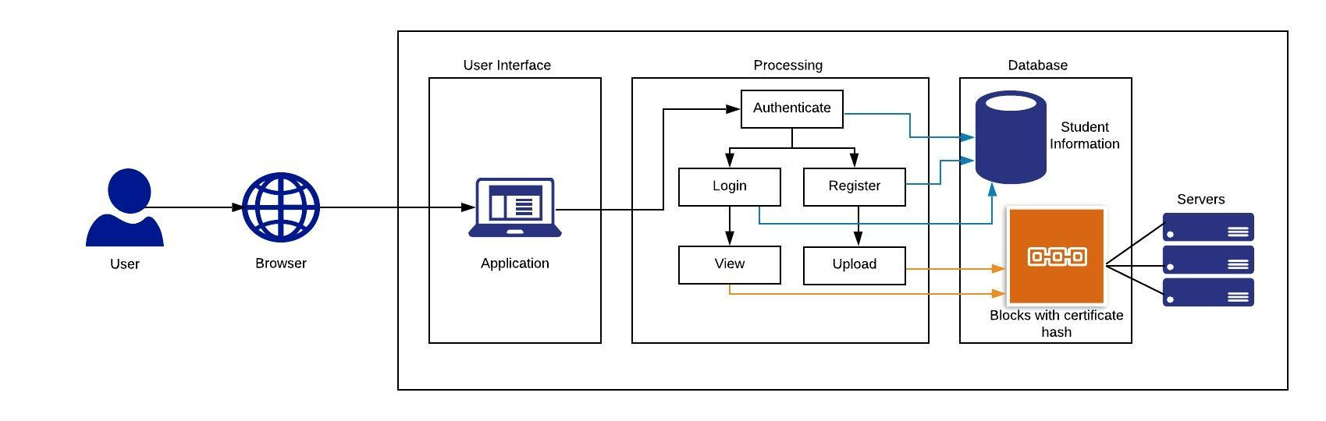 Fig.1. Architecture Diagram of the proposed system

If the user is any organization, then the organization should enter the username of the student, whose certificates they want to view. Upon entering the student username, the organization is able to view the select details of the student and the certificates uploaded by the student. This way, the external organization is not able to make any changes, or upload extra certificates in the student’s account. Likewise, the student will not be able to modify already uploaded certificates, thus ensuring there is no fraudulency on the side of the student users also.
Since the system uses blockchain technology, the certificates are stored in decentralized network, where all the nodes consist of the data uploaded. This ensures that the data is accessible at all times, and even if one node fails, other nodes are able to provide the data.
The certificates need to be uploaded in the system by the students after the initial one-time manual verification of the certificates by authorized verifiers. The username and password are assigned to the user based on their school code and mobile number. The user needs to change their password after new user registration, as both the username and password are set as the same.

Results and Discussions

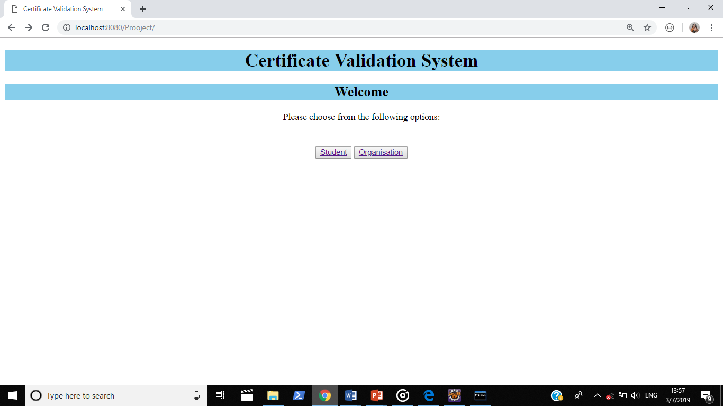Fig.2. The above depicts the welcome page of the system. In this page, the user is provided with the option to choose if they are a student or an organization.

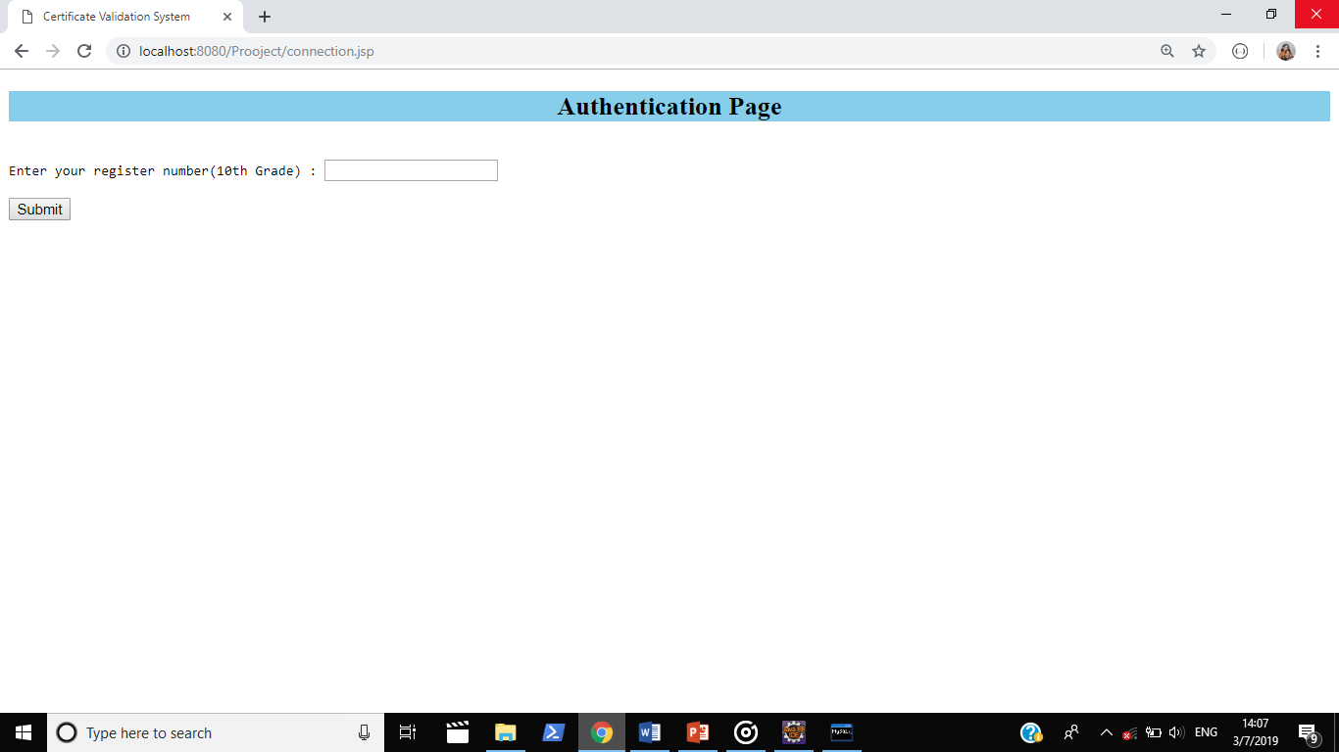
Fig.3. The above figure depicts the first step of authentication, where the student is asked to enter their 10th grade register number to ensure that he is a student.

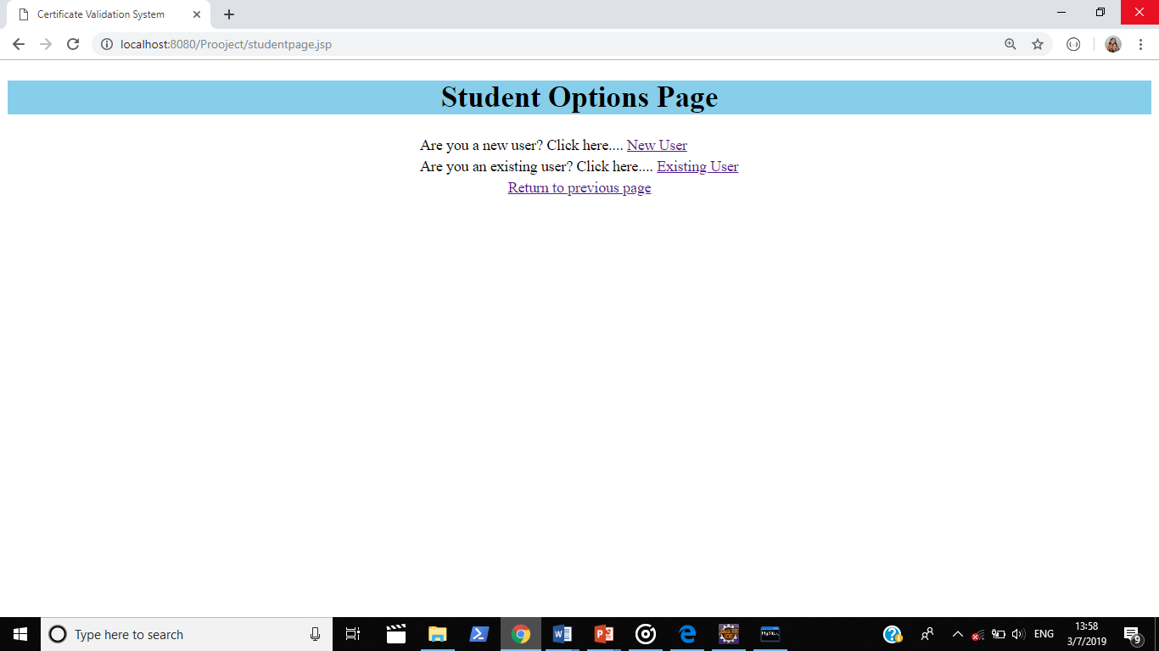
Fig.4. In the above figure, the student is provided with the option of a new user or an existing user.

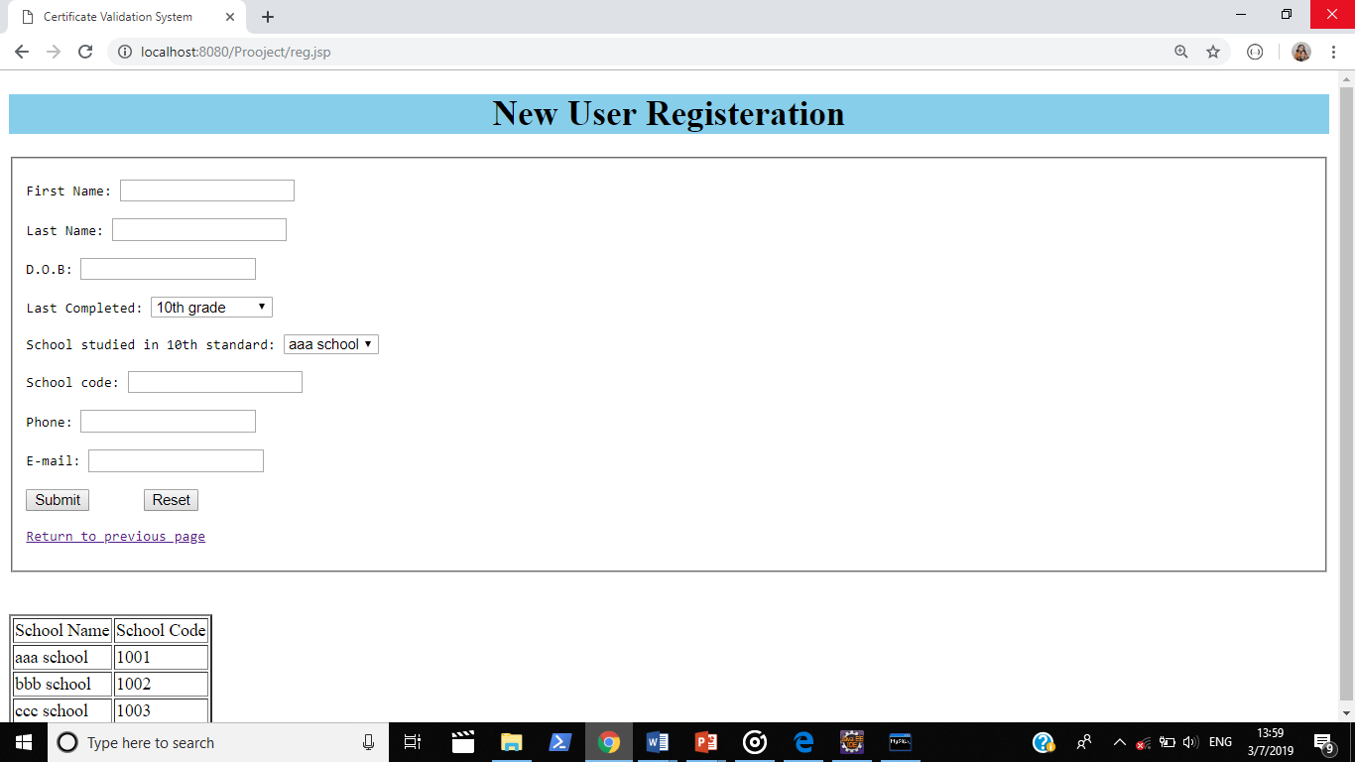
Fig.5. The above picture depicts the new user registration page for the student user. The school code is provided beneath the registration form. The student is expected to identify the correct school code and fill it in the form.

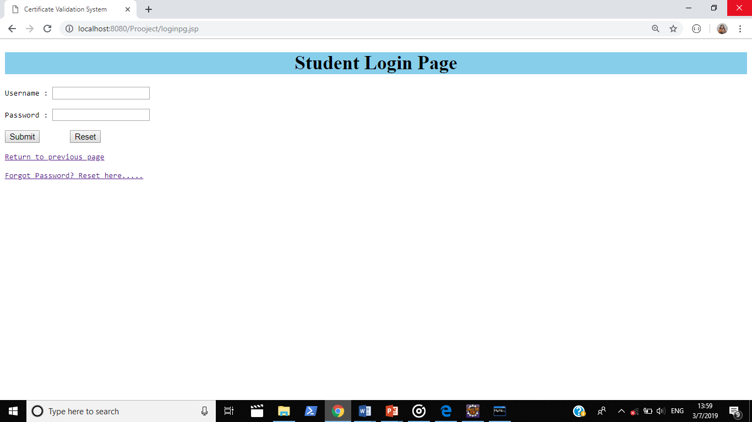
Fig.6. The above picture depicts the login page for the student user. The initial username and password are the concatenation of the school code and the student’s mobile number.
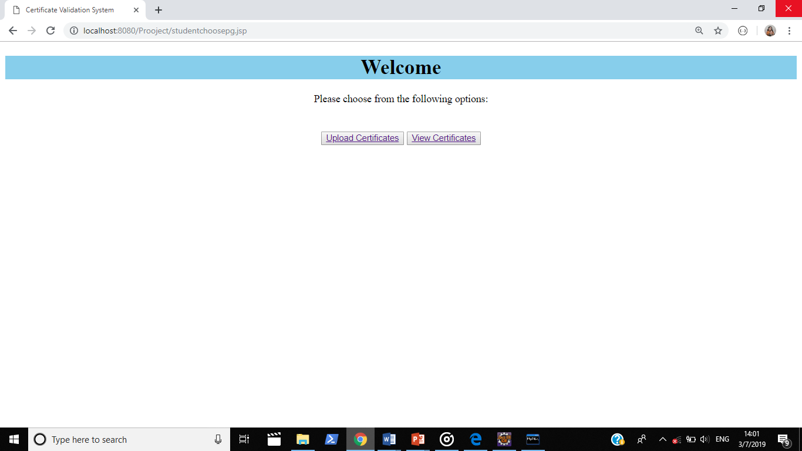Fig.7. The above figure is the student portal, that is displayed after logging into the system. The student is able to view or upload the certificates.

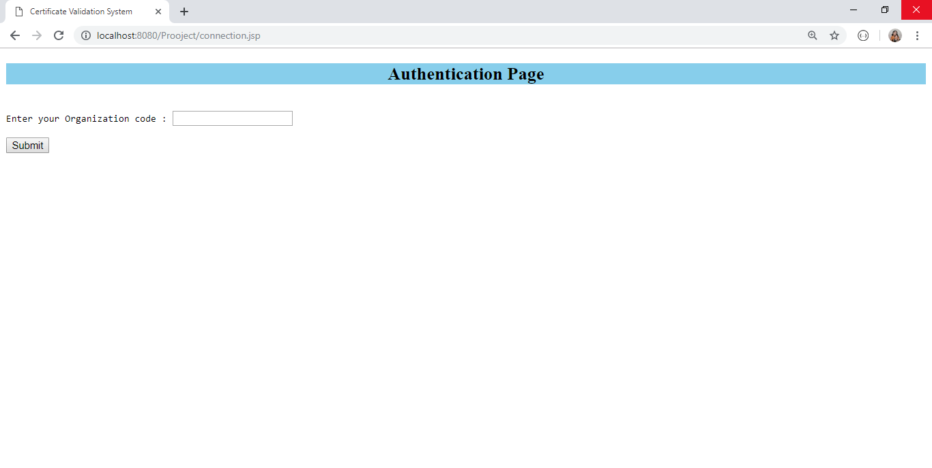

Fig.8. The above figure denotes the first step authentication for the organization wishing to access particular student’s accounts.

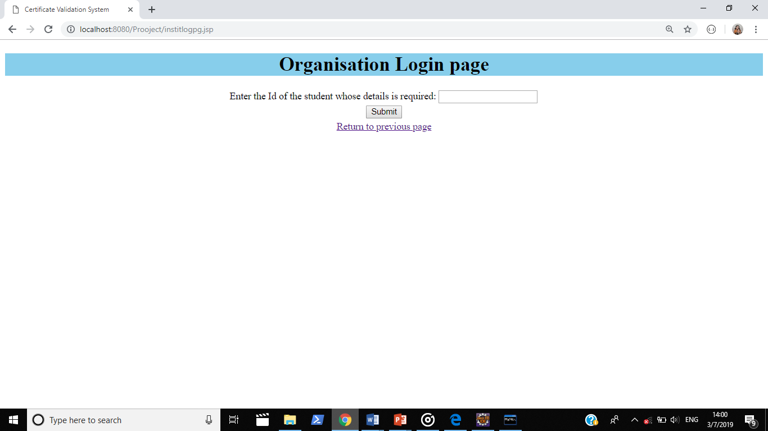
Fig.9. The above picture is the login page for the organisation. The organisation is expected to know the username of the student, thus being able to access the certificate of the required student.

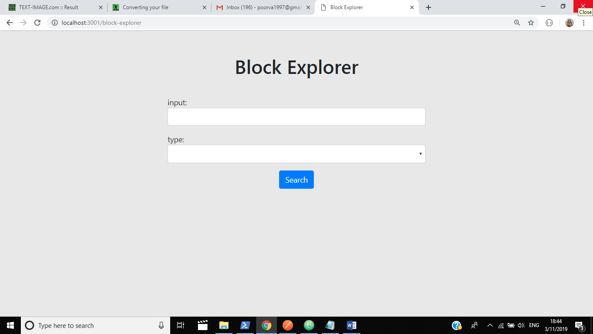
Fig.10. The above figure shows the display for the page where the organisation will be able to search for the student’s certificate through the student id.

References

- Azzah Al Ghamdi and Thomas Thomson in “The Future of Data Storage: A Case Study with the Saudi Company” [1], investigates the data storage methods and future requirements for one of the largest oil companies in the world, Saudi SA Oil Company. But the data is stored in a centralized storage, backup data has lot of constraints, security is provided through checksum.
- Matthew G.Borlick, Lokesh M.Gupta, Roger G.Hathorn and Karl A.Nielsen in the “Patent No . : US 10 , 171 , 585 B2”[2] proposes a system which stores different parts of data in various clouds. But it is unknown at what place the data is stored, if any attacks are made on the data and the data is stored only for a particular time period
- Xiaoqi Li, Peng Jiang, Ting Chen, Xiapu Luo and Qiaoyan Wen in “A Survey on the Security of Blockchain Systems” [3], has made a systematic study on the security threats to blockchain and survey the corresponding real attacks by examining popular blockchain systems is done. But it has been observed that the Consensus mechanism PoW is a waste of computing resources and not all of the data stored in blockchain is valid.
- Wasim Ahmad Bhat in “Capacity barriers in hard disks: problems, solutions and lessons” [4], has studied and investigated the storage problems in hard disks and proposed solutions to overcome the hardships faced in hard disks.
- Under the Government of India, the Ministry of Railways has passed the “Digital Signature Certificate Policy for Railway Units” [5], under which it has been stated that digital signatures have been approved for all the railway units.
- Wasim Ahmad Bhat, in his paper “Long-term preservation of big data: prospects of current storage technologies in digital libraries” [6], has investigated the prospects of current storage technologies for long-term preservation of big data in digital libraries and has come to the conclusion that current storage technologies might not fulfil the long-term storage of library data in the future.
- Mehran Alidoost Nia, Ali Sajedi and Aryo Jamshidpey in their “An Introduction to Digital Signature Schemes” [7], has compared different types of schemes based on security level, efficiency, difficulty of algorithm and so on. But no mention on the combination of two or more schemes, which is much more advanced.
- Samit Shivadekar, Stephen Raj, Abraham and Sheikh Khalid has proposed an E-Governance system in “Document Validation and Verification System”, [8] where 'E-Governance system' will be an online platform for deliverance of Government to Citizen Services and storage of digital certificates, documents etc. But there is the high initial cost of implementing such a system, as is typical of all computerized systems.
- Rongmao Chen, Yi Mu, Guomin Yang, Willy Susilo and Fuchun Guo in there “Strongly Leakage-Resilient Authenticated Key Exchange” [9], has presented a practical instantiation of the general framework based on the Decisional Diffie-Hellman assumption without random oracle. But The output size of the leakage function and Challenge dependent leakage security of AKE protocols.
- Tongjin Lee and Jun Iio has designed a prototype for document management system for small scale archives with open source software in “MAD4SA: a prototype of document management system for small-scale archives” [10]. Also, evaluation of the system is made in the perspective of the administrators. But this system is designed only for small scale storage and not for huge amount of data.
- Nwachukwu-Nwokeafor K.C and Igbajar Abraham has designed an online certificate verification system based on the verification process adopted by the university to verify the results in “Designing an Automatic Web-Based Certificate Verification System for Institutions “, [11]. But there is a high initial cost of implementation and users need to be educated about the usage of the system. The system is also vulnerable to attacks and change of data.
- Abhishek Roy and Sunil Karforma have made a thorough study of the industry standard digital signature schemes to obtain optimum security level for the electronic mechanisms and explored its probable applications in various domains in “A Survey on Digital Signatures and its Applications”, [12].
- Nicholas Mwankiki Musee in “An Academic Certification Verification System Based on Cloud Computing Environment “, [13] has Developed prototype which is used as SaaS to provide certificate verification. But the failure of central server will affect the whole system greatly and also the location of documents will be unknown.
- George D. Gollin has studied and concluded that Public-key cryptography provides a technical solution to the problem of authenticating academic documents such as transcripts and diplomas in “Verification of the integrity and legitimacy of academic credential documents in an international setting”, [14]. But during that period of time it was not promoted as Electronic Transcript Technology has not yet developed to a higher level.
- The possibility of using only private keys in the data transmission in digital signature is a new concept that is being researched with recently. The usage of digital signatures is already incorporated in blockchain. But the usage of new concept brings about more security in blockchain. [15].

